How to run the code:

* Create virtual environment and activate it.
* Install the libraries found in the requirements.txt file: pip install -r requirements.txt
* Run the script as command: python.exe challenge.py
* You can use ide too such as VSCODE, etc.

Output:

Immediately you run the file, the prompt will appear as below screenshot.

Prompt 1 - question and choices:

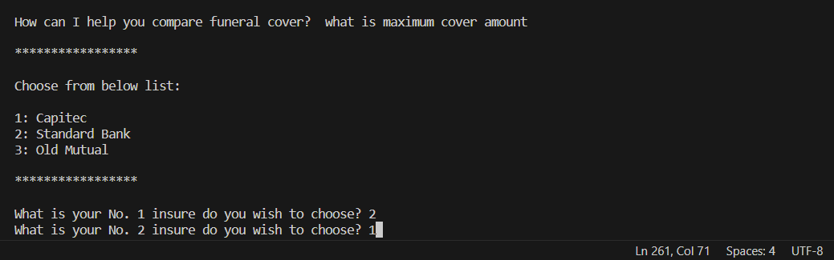

Prompt 1 – answer:

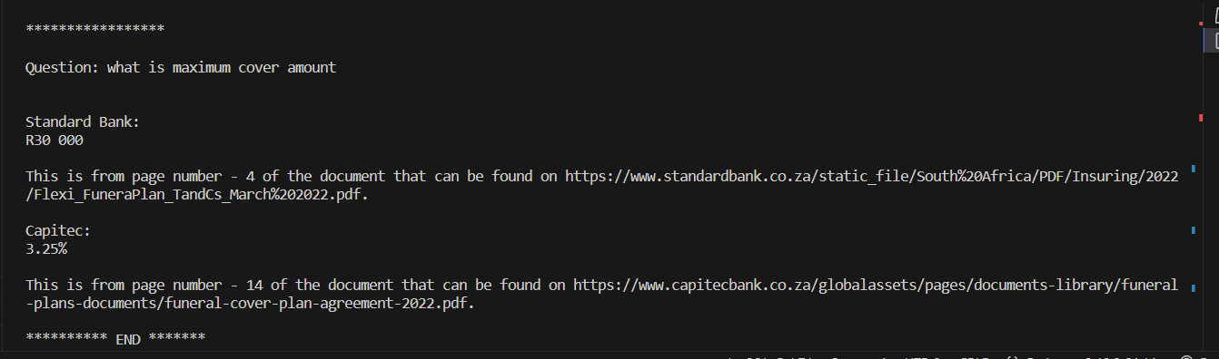

Prompt 2 - question and choices:

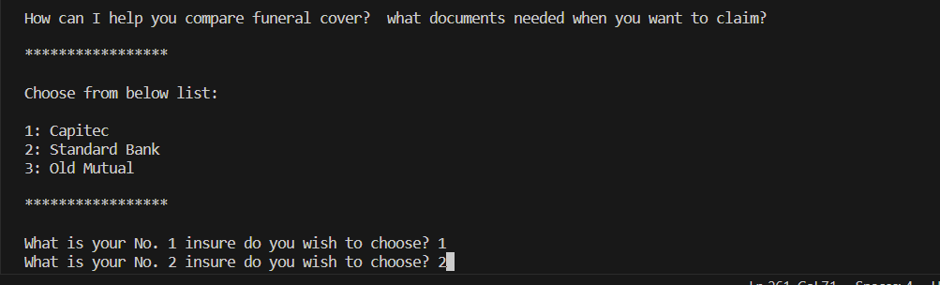

Prompt 2 - answer:

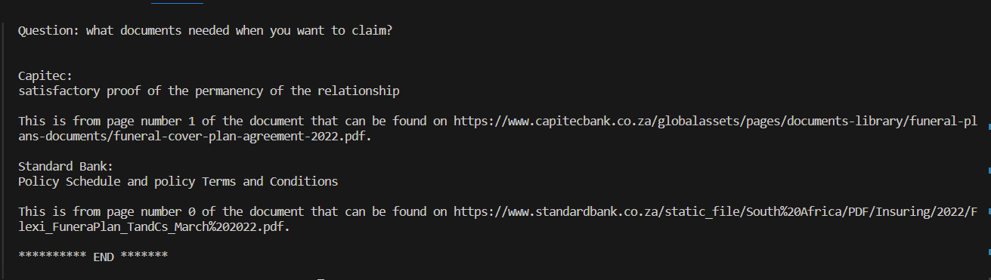

As the two answers above, the solution is still doing poor in terms of answering the question. This is because it is using transformers model, and it was not trained on the policy document. More work needs to be done to train transformers based on the document content. Same with web scrapping. In the document search, there is option for using ChatGPT too, this need to be configured as well. The prototypes are ready.

Note:

If you want to add more insures into the option list, do so by adding them into the json file in the same directory. File name is insures.json.

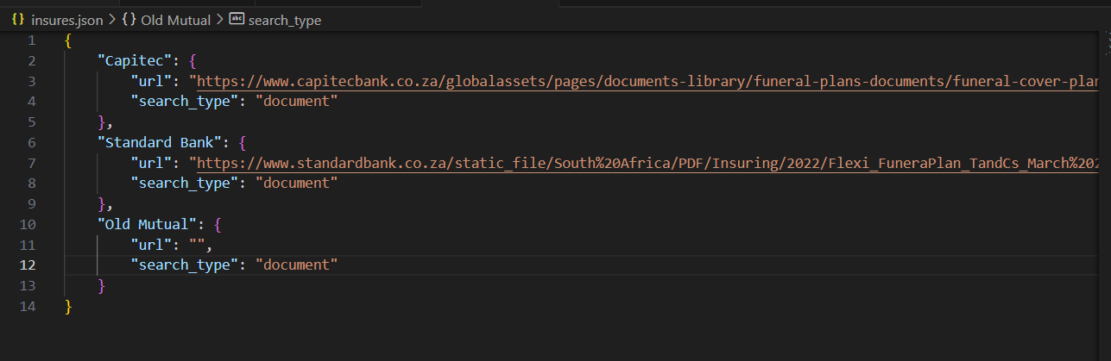

You should add name of insure, then url to the pdf, and then search type.

Search type will be based on 3 strategies. Search answer from the document or using web scrapping and/or also using APIs. The solution will be open to add more search type.

If search type or url is invalid in the json file. The web scrapping strategy will be used, which simply searches the question using google search.